**TITLE: Smart Door Locking System**

**IOT PROJECT REPORT**





**Department Of**

**Electronics And Communication**

**Engineering**

**Course Code & Course Name:**

**22SC1209 IOT Workshop**

**ACKNOWLEDGEMENTS**

It is great pleasure for me to express my gratitude to our honourable President **Er. Koneru Satyanarayana Sir**, for giving the opportunity and platform with facilities in accomplishing the project-based laboratory report.

I express the sincere gratitude to our Principal **Dr A. RAMA** **KRISHNA Sir,** for his administration towards our academic growth.

I express my sincere thanks to our project supervisor **Dr J.Aditya** **Sir**, for his novel association of ideas, encouragement, appreciation and intellectual zeal which motivated us to venture this project successfully.

Finally, it is pleased to acknowledge the indebtedness to all those who devoted themselves directly or indirectly to make this project report success.

**Yours Sincerely,**

2210040015-D. Bharath

**2210040017-B. Namo Sai Reddy**

2210040018-K. Parthav

**AIM:** This project is to create a Smart locking System that can be unlocked with a password entered through a keypad. The system should be able to grant access when the correct password is entered and deny access otherwise.

**APPARATUS:** 1. Arduino Uno board

**2.** Keypad

**3.** Servo motor

**4.** LCD display

**5.** LED lights (green and red and blue)

**6.** Buzzer and Resistors

**7.** Jumper wires

**8.** Breadboard

**9.** 9V battery or power supply

**Circuit Diagram:**

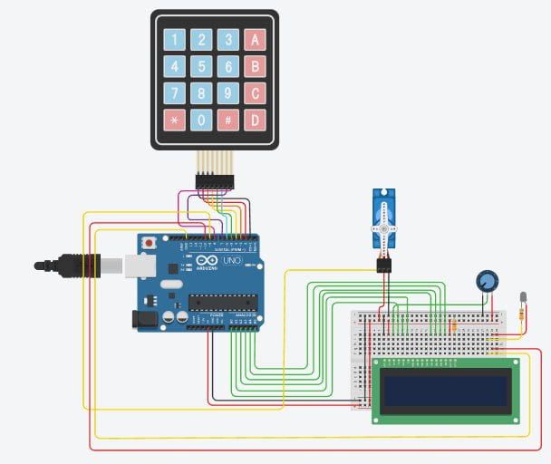

**Procedure:**

1.Connect the components according to the circuit diagram.

2.First Connect the 4x4 keypad to the 8 digital pins of the Arduino.

3. As there is more requirement for Power Source to the components than available, we short circuit the below region of Breadboard with 5V from Arduino.

4.As there is more requirement for ground than available, we short circuit the below region of Breadboard with one ground from Arduino.

5.We Connect the Servo Motor using any pins form the Arduino and a ground from the Short-Circuited Region of the Breadboard.

6.Next we connect the buzzer using the both positive and negative to any of the pins of Arduino.

7.We connect three LEDs using the three resistors to the power and ground of the Short-Circuited Region of the Breadboard.

8.Connect the LCD Display to the power source, ground and digital pin of the Arduino.

9.We need Install the Arduino Application from the official website of the Arduino and download the Version 2.0.4.

10.After Installing the .exe file, run it setup it by reading the following guidelines given and instructions.

11.You Need Download the Keypad.h, Wire.h LiquidCrystal_I2C.h, and Servo.h. library files from the Library Manager of the Arduino application.

13. Write a code for the required functions using Arduino and

assign the pins to the components.

14.Compile the Code and Upload it to the Arduino by selecting the proper port.

15.Finally keep the project prototype on box to showcase its working.

**Code For the Project:**

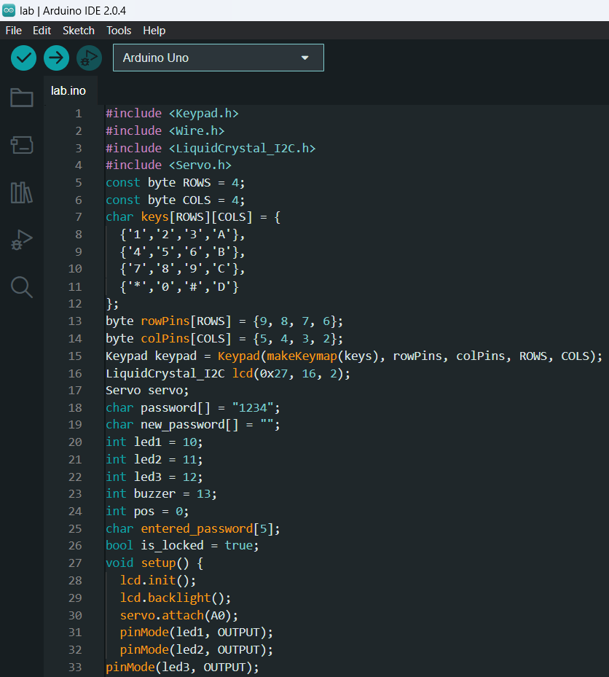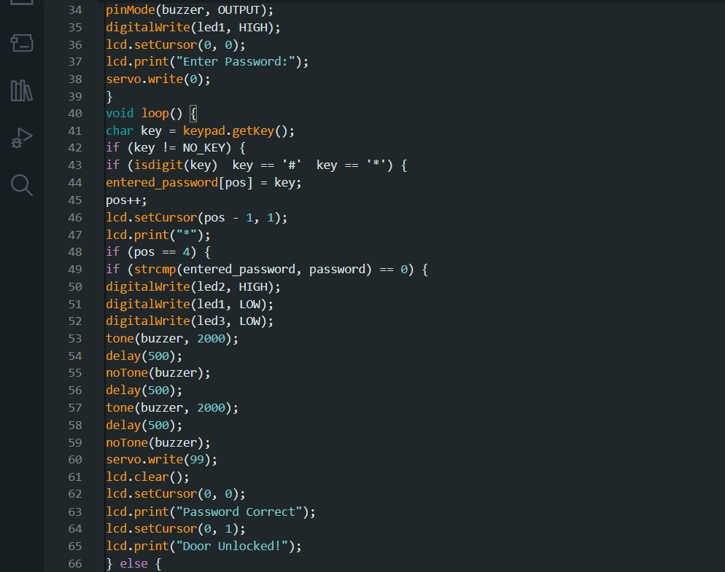

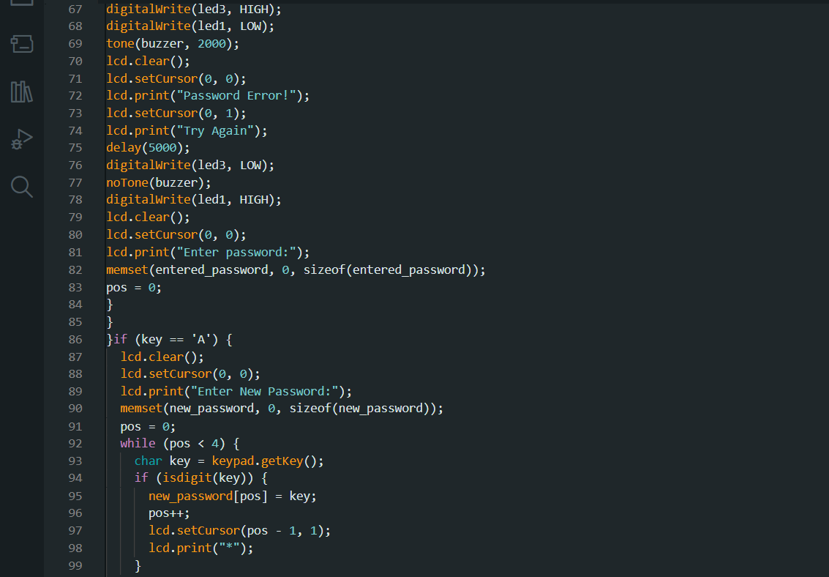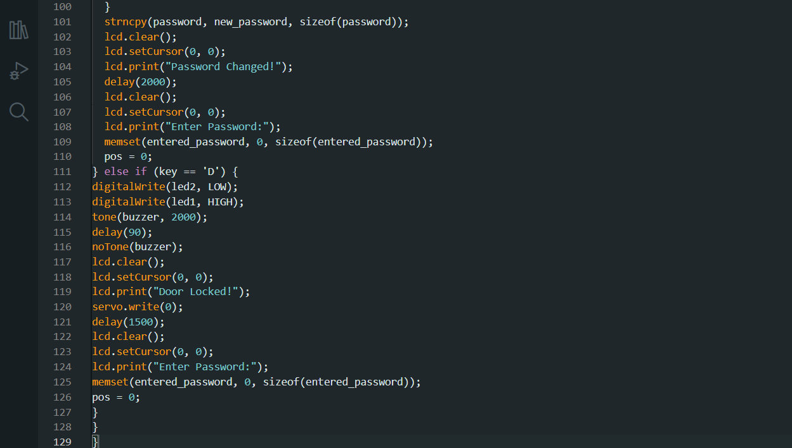

**Precautions:**

1.Always use proper safety precautions when working with electronic components.

2.Be careful when connecting the components to the breadboard or the Arduino board to avoid short circuits.

3.Ensure that the power supply is disconnected when making changes to the circuit or the code.

4.If Possible do wear gloves to avoid the electrostatic force while working with the electrical components.

5.Do the Connections as per the circuit diagram and upload the code after complier showing no errors.

7.Assigning of the pins to the particular components in the code should be checked twice before uploading it.

**Instructions To Use the Lock**:

1.Power up the system and test it.

2.When is the system starts the Green LED will glow indicating the door is locked.

3.By Default the password is set to 1234.

4.Enter the correct password to unlock the system and observe the servo motor turning to open the lock and Blue LED will glow and hear the buzzer sound 2 times, indicating access has been granted.

5.The Lock remains unlock until you press the Lock Function, in this project character D is assigned as the Re-Lock Function.

6.You Can even change the password using character A in the keypad and assign a new password.

7.Enter the incorrect password to see the Red LED will be lit up and hear the buzzer sound until the correct password is entered, indicating access has been denied.

**Observations:**

1.We can observe that the device unlocks the door by rotating servo motor.

2.The system will allow only authorized persons to enter the correct password and grant access.

3.The system will deny access to unauthorized persons and raise an alarm by turning on the red LED and sounding the buzzer.

4.We can also observe that the device keeps the door unlocked until the lock function button is pressed by the user.

**Result**:

Successfully we did the Smart lock system using Arduino with passcode changeable feature.

**Real Time Applications**:

1.Hassle Free from Keys

2.Prevention of Robbery

3.To Secure Private Places

4.High Security Level

5.Convenient and Efficient

**REPORT DONE BY:**

2210040015- BHARATH

**2210040017-NAMO SAI REDDY**

2210040018-PARTHAV

**REPORT SUBMITED TO:**

**DR. JAPA ADITYA – 6730**